|  |
| --- |
| Experiment No.5 |
| Implement Bi-Gram model for the given Text input |
| Date of Performance: |
| Date of Submission: |

CSDL7013: Natural Language Processing Lab



Aim: Implement Bi-Gram model for the given Text input Objective: To study and implement N-gram Language Model.

Theory:

A language model supports predicting the completion of a sentence.

Eg:

* Please turn off your cell _____
* Your program does not ______

Predictive text input systems can guess what you are typing and give choices on how to complete it.

N-gram Models:

Estimate probability of each word given prior context. P(phone | Please turn off your cell)

* Number of parameters required grows exponentially with the number of words of prior context.
* An N-gram model uses only N1 words of prior context.

○ Unigram: P(phone)

○ Bigram: P(phone | cell)

○ Trigram: P(phone | your cell)

* The Markov assumption is the presumption that the future behavior of a dynamical system only depends on its recent history. In particular, in a kth-order Markov model, the next state only depends on the k most recent states, therefore an N-gram model is a (N1)-order Markov model.

N-grams: a contiguous sequence of n tokens from a given piece of text

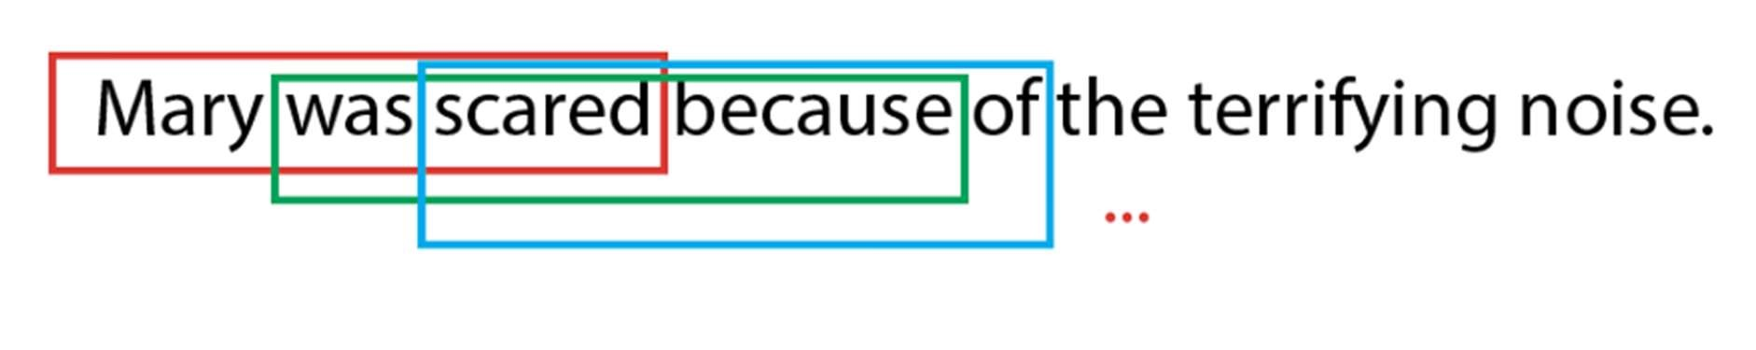

Fig. Example of Trigrams in a sentence

CSDL7013: Natural Language Processing Lab

Parts of Speech

Tag|Meaning|English Examples

ADJ|adjective|new, good, high, special, big, local

ADP|adposition|on, of, at, with, by, into, under

ADV|adverb|really, already, still, early, now

CONJ|conjunction|and, or, but, if, while, although

DET|determiner, article|the, a, some, most, every, no, which

NOUN|noun|year, home, costs, time, Africa

NUM|numeral|twenty-four, fourth, 1991, 14:24

PRT|particle|at, on, out, over per, that, up, with

PRON|pronoun|he, their, her, its, my, I, us VERB|verb|is, say, told, given, playing, would .|punctuation marks|. , ; !

X|other|ersatz, esprit, dunno, gr8, univeristy

text = "TON 618 (short for Tonantzintla 618) is a hyperluminous, broad-absorption-line, radio-loud quasar and Lyman-alpha blob located ne Importing necessary dependencies

import nltk

from nltk.tokenize import word_tokenize Word Tokenization

nltk.download('punkt') words = word_tokenize(text)

[nltk_data] Downloading package punkt to /root/nltk_data...

[nltk_data] Unzipping tokenizers/punkt.zip. Parts of Speech Tagging

nltk.download('universal_tagset') nltk.download('averaged_perceptron_tagger') tagged_words = nltk.pos_tag(words, tagset = 'universal')

[nltk_data] Downloading package universal_tagset to /root/nltk_data...

[nltk_data] Unzipping taggers/universal_tagset.zip.

[nltk_data] Downloading package averaged_perceptron_tagger to [nltk_data] /root/nltk_data...

[nltk_data] Package averaged_perceptron_tagger is already up-to-

[nltk_data] date!

tagged_words

[('TON', '.'),

('618', 'NUM'),

('(', '.'),

('short', 'ADJ'),

('for', 'ADP'),

('Tonantzintla', 'NOUN'),

('618', 'NUM'),

(')', '.'),

('is', 'VERB'),

('a', 'DET'),

('hyperluminous', 'ADJ'),

(',', '.'),

('broad-absorption-line', 'ADJ'),

(',', '.'),

('radio-loud', 'ADJ'),

('quasar', 'NOUN'),

('and', 'CONJ'),

('Lyman-alpha', 'NOUN'),

('blob', 'NOUN'),

('located', 'VERB'),

('near', 'ADP'),

('the', 'DET'),

('border', 'NOUN'),

('of', 'ADP'),

('the', 'DET'),

('constellations', 'NOUN'),

('Canes', 'NOUN'),

('Venatici', 'NOUN'),

('and', 'CONJ'),

('Coma', 'NOUN'),

('Berenices', 'NOUN'),

(',', '.'),

('with', 'ADP'),

('the', 'DET'),

('projected', 'VERB'),

('comoving', 'NOUN'),

('distance', 'NOUN'),

('of', 'ADP'),

('approximately', 'ADV'),

('18.2', 'NUM'),

('billion', 'NUM'),

('light-years', 'NOUN'),

('from', 'ADP'),

('Earth', 'NOUN'),

('.', '.')]

for t in tagged_words:

print(t)

('TON', '.')

('618', 'NUM')

('(', '.')

('short', 'ADJ')

('for', 'ADP')

('Tonantzintla', 'NOUN')

('618', 'NUM')

(')', '.')

('is', 'VERB')

('a', 'DET')

('hyperluminous', 'ADJ')

(',', '.')

('broad-absorption-line', 'ADJ')

(',', '.')

('radio-loud', 'ADJ')

('quasar', 'NOUN')

('and', 'CONJ')

('Lyman-alpha', 'NOUN')

('blob', 'NOUN')

('located', 'VERB')

('near', 'ADP')

('the', 'DET')

('border', 'NOUN')

('of', 'ADP')

('the', 'DET')

('constellations', 'NOUN')

('Canes', 'NOUN')

('Venatici', 'NOUN')

('and', 'CONJ')

('Coma', 'NOUN')

('Berenices', 'NOUN')

(',', '.')

('with', 'ADP')

('the', 'DET')

('projected', 'VERB')

('comoving', 'NOUN')

('distance', 'NOUN')

('of', 'ADP')

('approximately', 'ADV')

('18.2', 'NUM')

('billion', 'NUM')

('light-years', 'NOUN')

('from', 'ADP')

('Earth', 'NOUN')

('.', '.')

**Conclusion:**

A bi-gram model is a language model that examines sequences of two adjacent words in a given text. By analyzing word pairs, it captures some level of contextual information. However, it has limitations, such as ignoring longer-range dependencies and lacking semantic understanding. Bigram models can be useful for simple tasks like text prediction or basic sentiment analysis, but for more advanced NLP applications